**HALMASHAURI YA WILAYA YA GEITA**

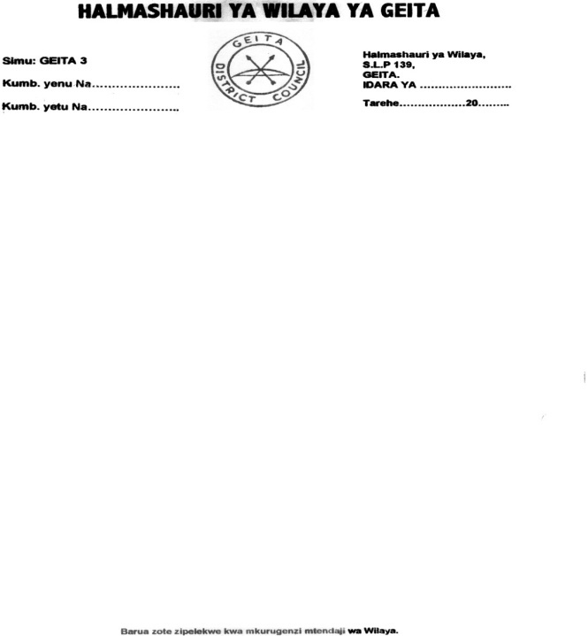

**KUITWA KWENYE USAILI**

Mkurugenzi Mtendaji wa Halmashauri ya Wilaya ya Geita anapenda kuwatangazia waombaji wa nafasi za Watunza kumbukumbu daraja la II na Makatibu Mahususi waliofanikiwa kuitwa kwenye usaili kufuatia tangazo lake la tarehe **13/04/2021** kuwa wanatakiwa kufanya mtihani wa kuandika (Written Interview) tarehe **02/06/2021** saa **02:00** asubuhi katika ukumbi wa Halmashauri ya Wilaya ya Geita - Nzera.

Aidha, watahiniwa watakaofaulu mtihani huo watatakiwa kufanya usaili wa mahojiano (Oral Interview) tarehe 03/06/2021 katika ukumbi wa Halmashauri ya Wilaya ya Geita.

Kwa wale ambao majina yao hayapo kwenye Tangazo hili watambue kuwa hawakukidhi vigezo, hivyo wasisite kuomba kwa mara nyingine nafasi zitakapotangazwa.

1. **WAOMBAJI WALIOITWA KWENYE USAILI - WATUNZA KUMBUKUMBU II**

|  |  |  |  |
| --- | --- | --- | --- |
| **Na.** | **JINA** | **JINSIA** | **ANUANI** |
| 1 | ELIUD BENSON CHATUNTA | KE | S.L.P.329, TABORA |
| 2 | NAOMI DENICE MKONO | ME | S.L.P.74, MUGUMU |
| 3 | ZENAIDA LUCIA MUGUSI | KE | S.L.P. 735, MWANZA |
| 4 | FRIDA C. NGONYANI | KE | S.L.P. 555, MWANZA |
| 5 | ZAINABU M. SALUMU | KE | S.L.P.36180, DAR ES SALAAM |
| 6 | REBECA ANDREW KWALEKA | KE | S.L.P.726, TABORA |
| 7 | ESTHER JOHN | KE | S.L.P. 244, MASWA |
| 8 | SHADRACK ABEL | ME | S.L.P.384, GEITA |
| 9 | CHRISTINA NZANAKI | KE | S.L.P.384, GEITA |
| 10 | ADELINA MORICE MWOROHA | KE | S.L.P.139, GEITA |
| 11 | AGATHA F. MGHASE | KE | S.L.P.51, GEITA |
| 12 | MKAMALA BUBERWA | KE | S.L.P.217, BUKOBA |
| 13 | SIJAONA EDWARD | KE | S.L.P.1213, MWANZA |
| 14 | RUKIA M. NGURUNGU | KE | S.L.P.90555, DAR ES SALAAM |
| 15 | REGINA DISMAS GAPI | KE | S.L.P. 70, GEITA |
| 16 | ADOLPHINA PETER NDAYANSE | KE | S.L.P. 185,KIBONDO |
| 17 | GRAIDES ODAS | KE | S.L.P.93, ILEMALELA |
| 18 | RHODA DUNIA | KE | S.L.P.1331, MWANZA |
| 19 | ASTRIDA J. KILLO | KE | S.L.P.688, MPANDA |
| 20 | MILEMBE MATHIAS MASHIKU | KE | S.L.P. 523, GEITA |
| 21 | INGIANAEL A. OMARY | KE | S.L.P.355, NZEGA |
| 22 | ROSE S. ALBETUS | KE | S.L.P.385, MWANZA |
| 23 | ALEX GEORGE KANANA | ME | S.L.P.109, SUMBAWANGA |
| 24 | MARTHA SAMWEL MESHA | KE | S.L.P. MUSOMA |
| 25 | SHAMIRA S. HASAAN | KE | S.L.P.1972, KILOSA |
| 26 | HALIMA R. ALMAS | KE | S.L.P 246, TABORA |
| 27 | ESTHER R. MALAGA | KE | S.L.P.92, MTWARA |
| 28 | DANILA PIUS FAUSTIN | KE | S.L.P.92, MTWARA |
| 29 | FARAJI MHINDA MRUA | ME | S.L.P. 33, TABORA |
| 30 | OLIVER B. SHIRIMA | KE | S.L.P. 404, BABATI |
| 31 | HUSNA ISMAIL | KE | S.L.P. 89, BUKOBA |
| 32 | TATU NASSIBU JABILLY | KE | S.L.P.329, TABORA |
| 33 | RUKIA SYLIVANUS | KE | S.L.P.01, MUGUMU |
| 34 | NEEMA ELLY KATIKIRO | KE | S.L.P. 735, MWANZA |
| 35 | VITALIS B. ALISTIDES | ME | S.L.P.269, BUKOBA |
| 36 | ESTER ALFRED KISIMA | KE | S.L.P. 1249, DODOMA |
| 37 | IRENE ANTHONY JOSEPH | KE | S.L.P.9633, DAR ES SALAAM |
| 38 | LEONARD H. ONNA | ME | S.L.P.742, MANYARA |
| 39 | ATANASIA B. KESSY | KE | S.L.P.1320, MOSHI |
| 40 | MARIAM NORBATH | KE | S.L.P.902, DODOMA |
| 41 | ZACHARIA KANYANYA IDIZIMA | ME | S.L.P.735, MWANZA |
| 42 | NEEMA JAMES WAMBURA | KE | S.L.P.212, TARIME |
| 43 | AIDAN DANIEL | KE | S.L.P. KATORO - GEITA |

1. **MAKATIBU MAHUSUSI DARAJA LA III**

|  |  |  |  |
| --- | --- | --- | --- |
| **Na.** | **JINA** | **JINSIA** | **ANUANI** |
| 1 | VERONICA FELICIAN MAYANI | KE | S.L.P.43, KASULU |
| 2 | JOYCE PHILIPO SAHANI | KE | S.L.P.DAR ES SALAAM |
| 3 | DEVOTHA JOSEPH | KE | S.L.P.139, GEITA |
| 4 | ACQUELINE GOODLUCK NKYA | KE | S.L.P.66723 DAR ES SALAAM |
| 5 | IRENEUS G. MASENGA | ME | S.L.P.3000, MOROGORO |

**MAMBO MUHIMU YA KUZINGATIA:**

1. **Wasailiwa wafike na vyeti halisi (original certificates) vya elimu, taaluma, hati za matokeo (transcripts) na cheti cha kuzaliwa.**
2. **Kwa wale waliosoma nje ya nchi wahakikishe vyeti vyao vimehakikiwa na Mamlaka husika (NECTA, NACTE)**
3. **Hati za matokeo ya kidato cha nne/sita testimonials, provisional results na statement of results havitakubaliwa.**
4. **Kila msailiwa atajigharimia kwa chakula, usafiri na malazi.**

Pia tangazo hili linapatikana kwenye mbao za matangazo na tovuti ifuatayo:-

[www.geitadc.go.tz.](http://www.geitadc.go.tz.)

Imetolewa leo tarehe **20/05/2021** na:



Donald L. Nssoko

**KAIMU MKURUGENZI MTENDAJI**

**HALMASHAURI YA WILAYA YA GEITA**

